Name___________________________________________Hour___________

Investigation 2 ACE/Reflection

You decide to earn some money by shoveling show. You earn $6.50 per hour. Make a table showing how much money you will make over time.

Graph your data, label the axes and name the graph.

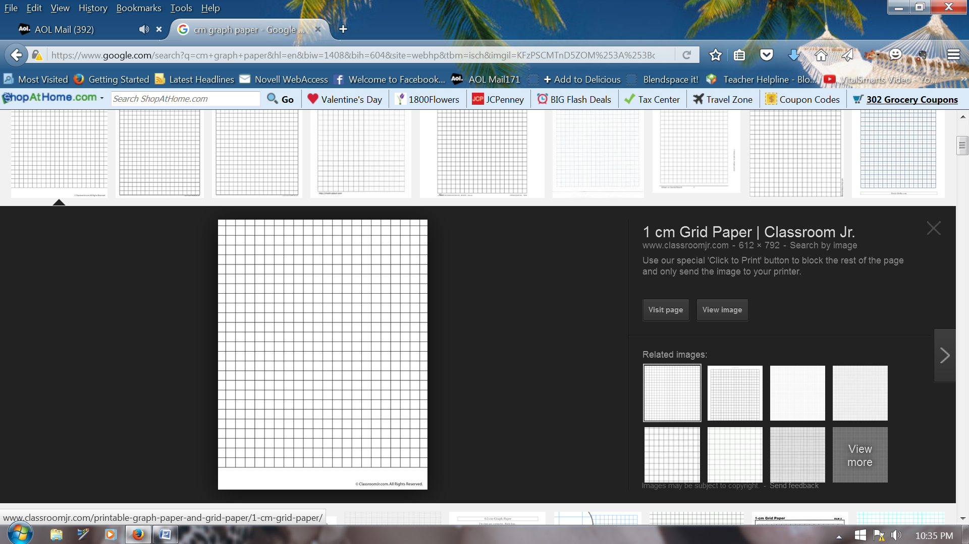

Does it make sense to connect the points? ________ Why or why not?

The graphs below show the progress of a car at different times during a drive. For each graph, describe the driver’s progress over the time interval.

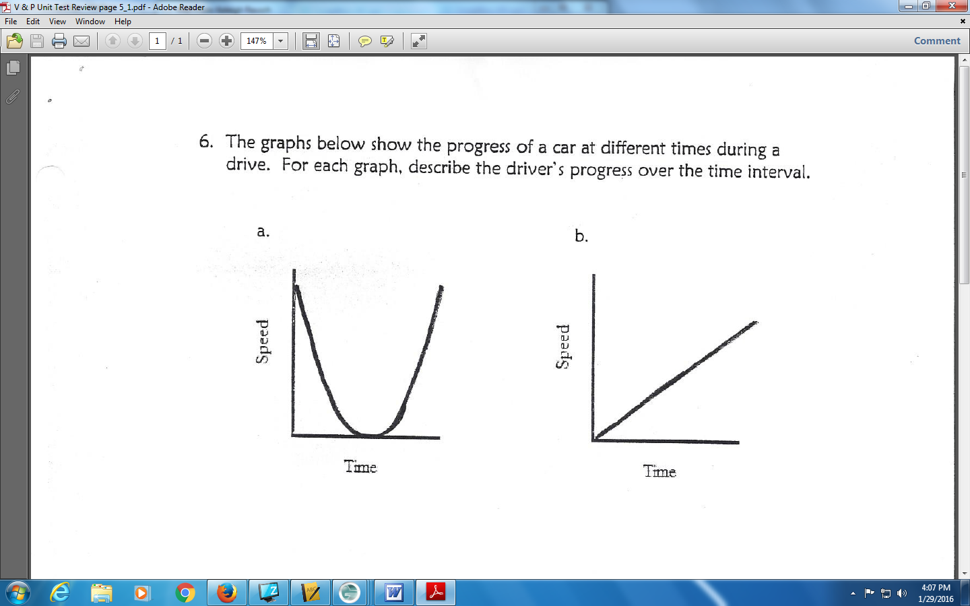

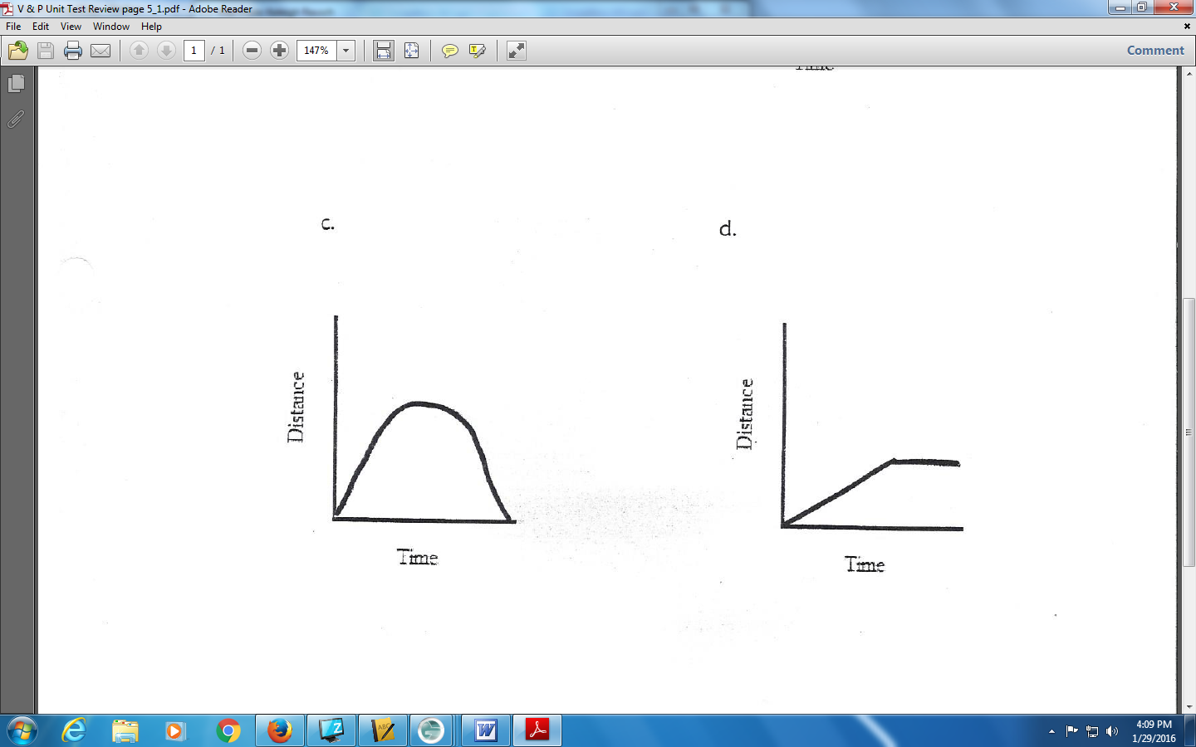

The graph shows how the temperature changed during an all-day hike by students.
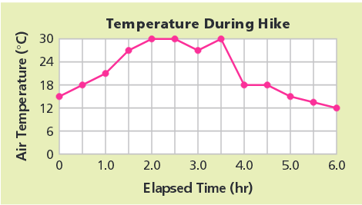

Make a table of the data in the graph.

Answer the questions and be sure to highlight your evidence in both the graph and table.
a. What was the maximum temperature and when did it occur?

b. When was the temperature rising most rapidly?

c. When was the temperature falling most rapidly?

d. When was the temperature about 24 degrees celecius?

e. The hikers encounter a thunderstorm with rain. When do you think this happened?

